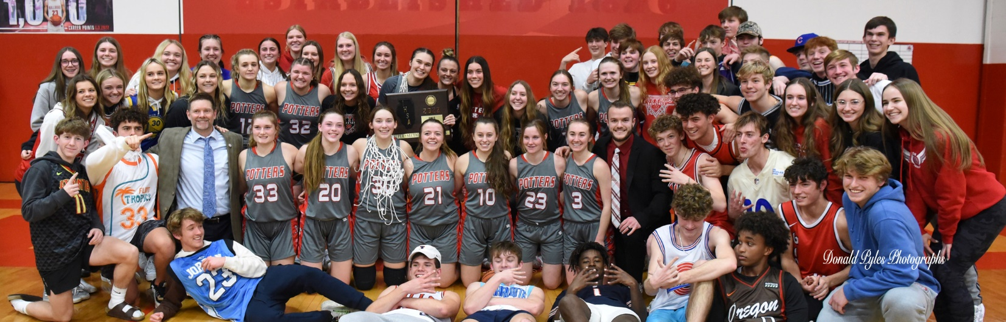
FUTURE CHAMPIONS
Morton Lady Potter
Summer Basketball Camps 2022

This is where the journey begins. All of our players were once summer campers like you. Join our championship players and coaches this summer to begin learning the Potter Way. You will learn fundamentals of basketball while meeting new friends and having FUN. All camps are instructed by Morton 709 coaches and players. Each camper will be treated with TLC (tender loving care) and it’s our hope for all campers to learn some basketball, meet new friends, and have fun while sparking a love for Lady Potter Basketball! We look forward to working with you!

Shooting & Offensive Skills Camp June 1st-June 3rd Grades 1-6 1pm-2:15pm $60
Grades 7-8 2:30pm-4pm $60

This camp is all about offense! Ballhandling, passing, footwork, moves & finishes and shooting fundamentals will be emphasized. Campers will be instructed on shooting mechanics along with an array of individual offensive skills designed to help each player succeed on the offensive end of the court. All campers will receive a t-shirt. THREE-day camp runs Tuesday – Friday and will utilize the High School Gyms as well as the Junior High Gyms. Grades 1-6 report to Junior High Gyms day one. Grades 7 & 8 report to high school gyms.

FUNdamental Camp 1 June 13th-16th Grades 1-8 9am-11am $75

Our FUNdamental Camp will consist of fun, action-packed FOUR days designed to develop each camper’s fundamental skills and overall playing ability. Fundamentals will be stressed but fun is main priority! Camp will include team-oriented situations as well as individual skill development and a variety of camp games. We want camp to be an enjoyable Potter experience working with our players and coaching staff. This is a great way to meet other kids interested in basketball and learn a bit of our Potter Way. All campers will receive a t-shirt at each camp. Four day camp runs Monday – Thursday and will utilize the High School Gyms as well as the Junior High Gyms. All campers should report to the high school West Gym on day one.

FUNdamental Camp 2 June 20th-23rd Grades 1-8 9am-11am $75

Our FUNdamental Camp 2 will consist of another fun, action-packed FOUR days designed to develop each camper’s fundamental skills and overall playing ability. Fundamentals will be stressed but fun is main priority! Camp will include team-oriented situations as well as individual skill development and a variety of camp games. We will tweak camp to offer a bit different experiences than FUNdamental Camp 1 yet will be a similar great Potter experience working with our players and coaching staff. This is a great way to meet other kids interested in basketball and learn a bit of our Potter Way. All campers will receive a t-shirt at each camp. Four day camp runs Monday – Thursday and will utilize the High School Gyms as well as the Junior High Gyms. All campers should report to the high school West Gym on day one.

Morton High School Potters Grades 9th -12th $100

Shooting & Offensive Skill Development June 1st-3rd 2:30pm-4:00pm

Individual Improvement/Team Concepts June 13th- 16th 11:15am-1:15pm
June 20th-23rd 11:15am-1:15pm

These 11 dates are for Morton High School aged players and are designed to help build our championship players and team. Individual skill development along with introducing team concepts will be emphasized. All players planning to play during the summer and winter are strongly encouraged to participate. These count as some of our IHSA contact dates and will serve as some summer practices. We will utilize both high school gyms. $100 covers it all!

Please direct all questions to Morton Head Coach Bob Becker
Email: Robert.becker@mcusd709.org Phone # 309-642-4432
Be sure to visit our Morton Lady Potter Basketball website! www.mortonladypotters.com

Morton Lady Potter Summer Basketball Camps 2022

Registration Form:
Camper Information:

Name_________________________________ Entering GRADE ______________________

T-shirt size circle Youth M Youth L Adult S Adult M Adult L Adult XL

Camper medical concerns? Please note any medical conditions or medications you want our staff to be aware of. __________________________________________________________________________________________________________________________________________________________

Parent/Guardian Information:
Contact Parent or Guardian Name _________________________Phone__________________

Secondary / Emergency Phone # (_____)________________________________

Please circle camp/s you are registering for.

Shooting & Offensive Skills Camp Grades 1-6 June 1st-3rd 1pm-2:15pm $60
Grades 7-8 June 1st-3rd 2:30-4:00pm $60

FUNdamental Camp 1 Grades 1-8 June 13th- 16th 9am-11am $75
FUNdamental Camp 2 Grades 1-8 June 20th- 23rd 9am-11am $75

Morton High School Potters Grades 9th -12th $100
June 1st-3rd 2:30pm-4:00pm June 13th- 16th & June 20th-23rd both 11:15am-1:15pm

$$ Payment Information $$
Checks are preferred and should be made payable to Morton High School Girls Basketball. Please seal in an envelope with camper’s first and last name included. If paying with cash, please seal exact amount in an envelope with camper’s first and last name.
Please turn in this form along with payment by May 18th at Morton High School main office.

Total Camp Fees: $__________

