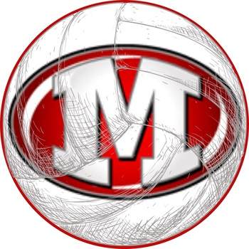
Morton High School

Volleyball Camp

All Camps will be held at Morton JUNIOR High School
Camps are ran by many of the current high school coaches and players
Camp Dates: June 27th-30th

Camp Summaries:
Players must be entering 1st grade or higher in the fall. Grade level suggestions are made, but if a 7th/8th grader does not have prior camp, club, or school volleyball experience, you may want to join Novice.
Beginner Camp- 1st, 2nd, 3rd Grade Camp- NEW! 9:00-9:45am/$35
The emphasis of this camp will be on volleyball fundamentals, form and fun. We will cover the basic skill development for passing, serving, attacking and moving.
Novice Camp- 4th, 5th & 6th Grade (and beginner 7th/8th): 10:15-11:15/$45
The emphasis of this camp will be on proper volleyball form and fundamentals. We will teach skill development for passing, setting, serving and attacking. Participants will also apply those skills in various drills and games. This is best for experienced 4th,5th and 6th graders as well junior high athletes that are new to the sport.
Experienced Camp- 7th & 8th Grade Camp: 12:00-1:30/$60
This camp will be geared toward a faster paced environment while still focusing on the necessary skills needed to become a successful volleyball player. The goal in this camp is to push athletes with prior volleyball experience to a higher level and attain more aggressive skills.
Potter Power Camp-High School: 3:30-5:30/$70
This camp is for our high school players including incoming freshmen. The camp is designed for players to continually compete in a fun environment while learning new ways to think about skills they use. Every drill will earn players points in skill categories to work towards becoming Premium Potter. Players will learn to compete on every ball, celebrate their own success, and celebrate the success of teammates.

*To guarantee a spot and camp shirt, please have registration in by June 3*

Registration Form:
Please check the box for the camp you are registering for. Register for grade you will be entering.

Beginner Camp (1st, 2nd, 3rd) $35
[ ]
Novice Camp (4th, 5th, 6th, beginner 7-8) $45
[ ]

Experienced Camp $60

Athlete’s Information:
First__________________________
Last___________________________
SHIRT SIZES (circle one):
*shirts only guaranteed if this is filled out and registered on time
YS YM YL AS AM AL AXL
[ ]

Potter Power Camp (HS) $70
[ ]
Parent/Guardian Information
Contact Parent or Guardian:
First/Last______________________
Email___________________________
Phone# (in case of emergency) (_______)_______________________
Medical Information
Please notify staff of any medical conditions or medications you want us to be aware of.
__________________________________
__________________________________
__________________________________

$ Payment Information $
*Checks preferred please, payable to Morton High School Volleyball. Please seal in an envelope with athlete’s first and last name.
*If paying with cash, please seal exact amount in an envelope with athlete’s first and last name. For siblings,please send a separate form for each player, but they can be sent in the same envelope.
Coaching Staff Contact Information:
Head: Jordan Williams | Asst: Courtney Kincaid | Asst: Claire Schmitt
jordan.williams@mcusd709.org | courtney.kincaid@mcusd709.org | claire.schmitt@mcusd709.org

